CO1 - ASSESSMENT TOOL OUTPUT PREDICTION
COURSE : DATA STRUCTURES
COURSE CODE : CSA0307
NAME: D Jeshurun Silas
REGISTRATION NUMBER : 192525324

Question 1 : Reverse A List
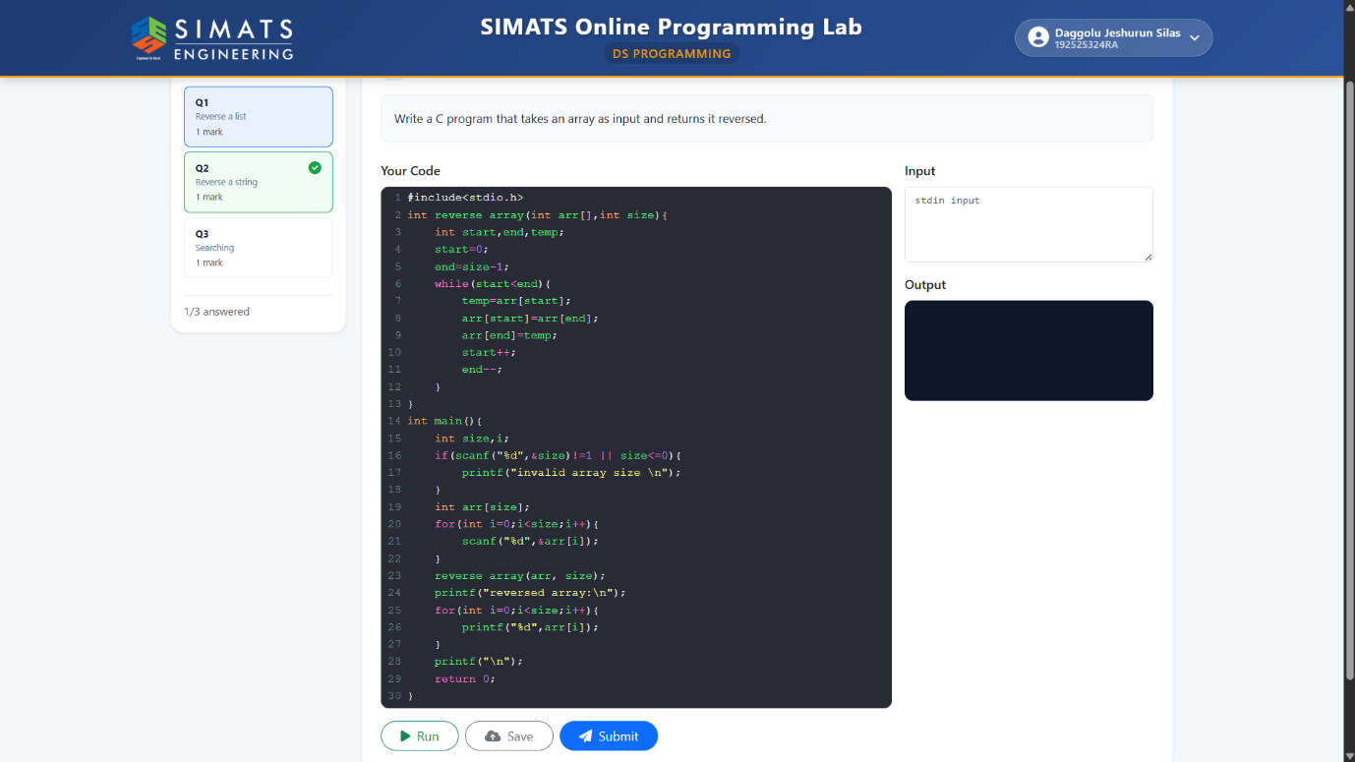

Question 2 : Reverse Of A String
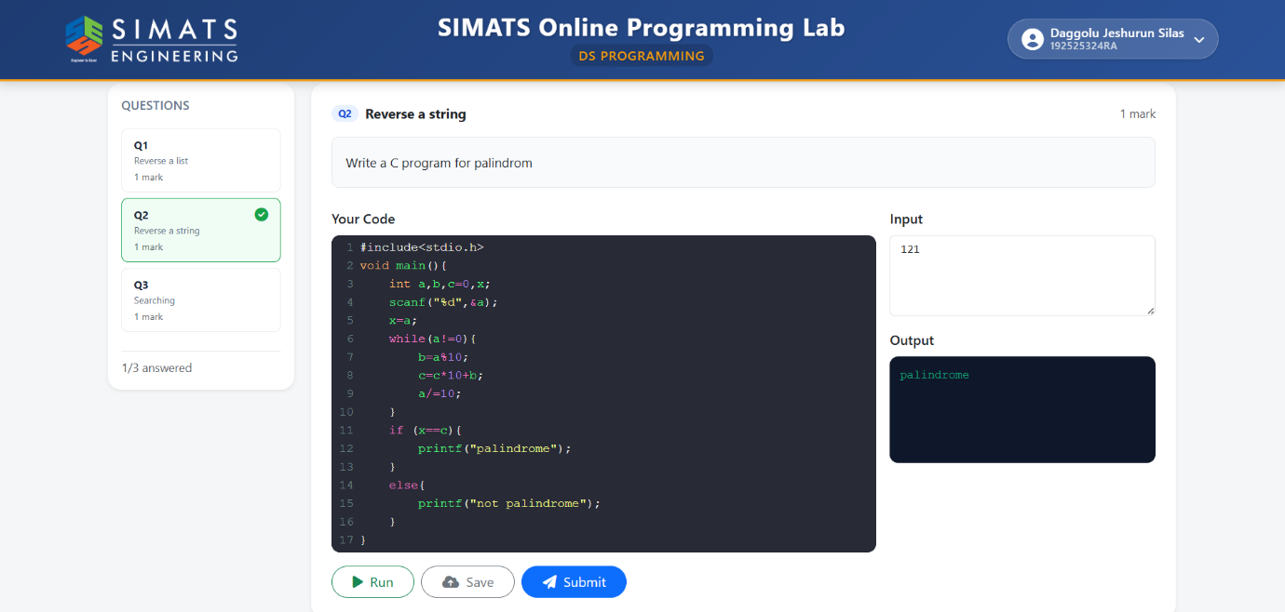

Question 3 : Searching Elements In An Array
